**File System Structure**

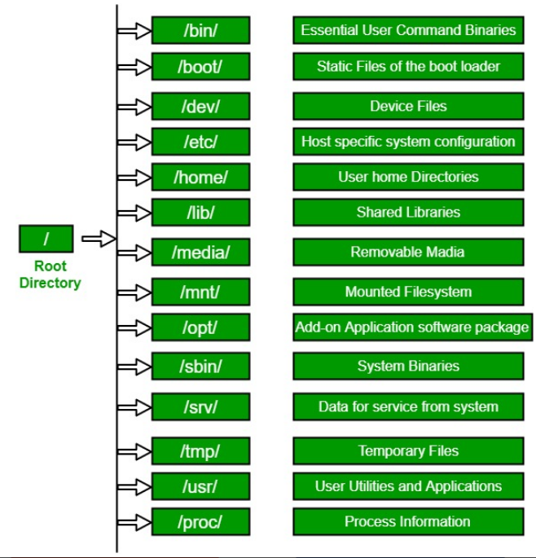

**File System Extensions**

* ext3, ext4, XFS => LINUX
* NTFS, FAT32 => Windows

**Linux File System Commands**

* cd path => change to this path
* Touch file or cp file or vi file => create a new file

Note: you can create multiple files in one command with touch command

* cp file/directory path => copy this file to path
* mv file/directory path => move this file to path
* rm -r file/directory
* mkdir => make a directory
* ls -ltr => list and separate the dictionaries and files. The color of directory is blue and the color of file is black
* find . -name “searched_name” => find the file. Dot means the current directory. You can change to any directory
* locate filename => show the filename location
* * => represents zero or more characters
* ? => represents a single character
* [] =>represents a range of characters
* \ => escape character
* ^ => the beginning of the line
* $ => the end of the line

**Basic Linux System Administration**

* | => this character is used to pipe the commands that enable you to make an option if you want to add new command to execute more than command in one time or filter the command. For example, ls -l | more. This will list files and directories but not all so you need to show more click on more icon
* ls -l | tail -1 => show only the last record of the list
* chmod rwx rwx rwx file_name => change the permission of the file according to user,group and others. x refers to execute and r refer to read and w refer to write.
* whatis command or man command or command –help => get the help command that helps you know the description of the command
* chown -r user_name directory/file => change the owner of the directory/file with recursive ownership change option
* chgrp -r group_name directory/file => change the owner of the directory/file with recursive ownership change option
* echo “text” > file_name => write a text into a file
* echo “text” >> file_name => write a text in a newline
* . => means current directory
* more file_name => show more of file information when you press on more icon
* head -number file_name => show a number from the first of file records
* tail -number file_name => show a number from the tail of file records
* cut -c[num] file_name => show the index number of every line
* grep “searched_word” file_name => search for word in a file
* sort file_name => sort lines/words in a file in an ascending type
* sort -r file_name => sort lines/words in a file in an descending type
* uniq file_name => show file information with distinct values
* wc file_name => count newline,words and byte inside the file
* diff file1 file2=> compare line with line between file1 and file2
* cmp file1 file2 => compare byte with byte between file1 and file2
* tar -cf archive.tar destination => compress file and put it into destination directory
* tar -tvf achive.tar destination =>lists all files inside the archive
* tar -xf or gzip -d or gunzip archive.tar destination => decompress file
* vi most common keys : I for insert, d for delete, r for replace, ESC for escape out of any mode, :q for quit without saving and :wq for quit with saving
* who => show what has happened and who make this happened
* last => the last thing happened and who did that
* id username => get all information about this user
* data => show the current date
* uname -a => show the OS of the VM with detailed information
* which command_keyword => show the directory of the command_keyword
* cal month_number year_number => show the calender of this year month

**Advance Linux System Administration**

* ps -ef => lists all running processes
* kill process_id => terminate the process whose process_id
* top => indicates the brief of the all processes
* crontab -e => create a new cronjob
* systemctl restart process_name => restart a process
* df -h => shows information about files mounted on the system devices
* netstat -rnv => show information about system network
* cat /proc/cpuinfo => information about cpu
* cat /proc/meminfo => information about memory
* hostnamectl set-hostname newhostname => change hostname
* dimdecode => show every thing
* ctrl+u => erase all the code you have write
* ctrl+c => stop/kill command
* ctrl+z => suspend the command
* ctrl+d => exit from interactive program
* echo $0 => show your bach
* alias alias_name = “command that would be aliased”. After that we can use alias_name instead
* alias alias_name = “command1;command2;commandn” => combine a lot of commands in one shot with using alias_name
* unalias alias_name => cancel the alias
* history => show history of commands
* ping link => to ensure that link is working or not
* ifconfig => show network information
* rpm -qa => show all the packages installed
* yum update -y => update system(preserve packages)
* cat /etc/redhat-release
* init 0 => shut down or halt
* init 1 => used in aliasing
* init 2 => multiuser without networking
* init 3 => multiuser with network
* init 5 => multiuser with network and GUI
* init 6 => reboot the system
* traceroute link => track the journey of the packet from the beginning to the end
* /etc/motd => here you can write the message of the day